DR. Shyama Prasad Mukherjee University, Ranchi

School of Management Studies
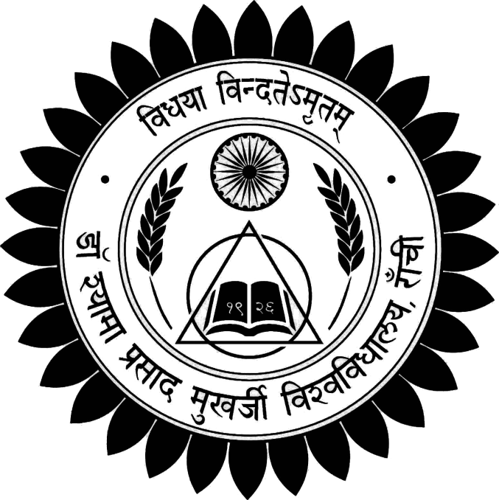

SHORT NOTES
IT FOR MANAGERS
SEMESTER – I, PAPER - 06
SUBMITTED BY – VIKRANT KUMAR RAVI
ASST. PROFFESOR, FACULTY OF MANAGEMENT STUDIES
MASTERS OF BUSINESS ADMINISTRATION
SCHOOL OF MANAGEMENT STUDIES
DSPMU

*The main objective- of this short note is to familiarize the students with the current and emerging trends in technologies as regards the information field, to equip them with the IT skills required for the managerial activities.

SYLLABUS

Unit-1 Introduction to Computers
Hardware - Software - Systems Software, Application Software and Packages. Fundamentals of operating system- windows, Unix/Linux. Introduction to World Wide-Internet operations. Data and Information-meaning & concept.

Unit-2 Programming language and generation
Lower level and high level language and different computer generation

Unit-3 Introduction to Memory Organization
Characteristic terms for various memory devices, main/primary memory, external/auxiliary memory, high speed memory, Introduction to I/O organization, CPU organization, ALU, control logics.

Unit-4 Telecommunication and Networks
Fundamental of Data Communication- Network Concepts and Classification, Telecommunications Media, Network Topologies.

Unit-5 Overview of Computer Applications in Public Services and Business
Office Automation applications - Word Processor (MS -Word), Spreadsheet & Presentation (MS PowerPoint).

Unit-6 Functional and Enterprise Management Systems
Introduction to Management Information System- Transaction Processing Information Systems, Accounting and Finance Systems, Marketing and Sales Systems, Production and Operation Management Systems, Human Resources Management Systems.

Unit-7 Introduction to Programming Concepts & flow charting
Models of computer data processing, flow charting technique-principles of flow charting, symbols used in flow charts, Benefits & limitations of flow chart, examples.

Unit-1 Introduction to Computers + unit 3. Introduction to Memory Organization

Computer

A computer is an electronic device, operating under the control of instructions stored in its own memory that can accept data (input), process the data according to specified rules, produce information (output), and store the information for future use1.

Functionalities of a computer
Any digital computer carries out five functions in gross terms:
  - Takes data as Input
  - Stores the data/instructions in its memory and use them when required.
  - Processes the data and converts it into useful information.
  - Generates the Output.
  - Controls all the above four steps.

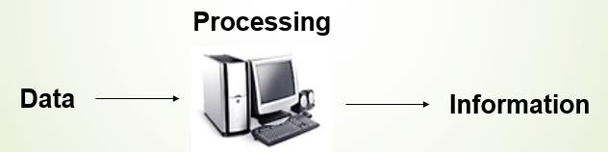

Computer Components
Any kind of computers consists of HARDWARE AND SOFTWARE.
Hardware:
Computer hardware is the collection of physical elements that constitutes a computer system. Computer hardware refers to the physical parts or components of a computer such as the monitor, mouse, keyboard, computer data storage, hard drive disk (HDD), system unit (graphic cards, sound cards, memory, motherboard and chips), etc. all of which are physical objects that can be touched.

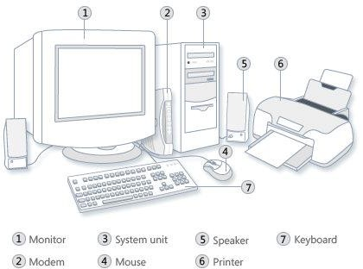

Input Devices
Input device is any peripheral (piece of computer hardware equipment to provide data and control signals to an information processing system such as a computer or other information appliance.
Input device Translate data from form that humans understand to one that the computer can work with. Most common are keyboard and mouse
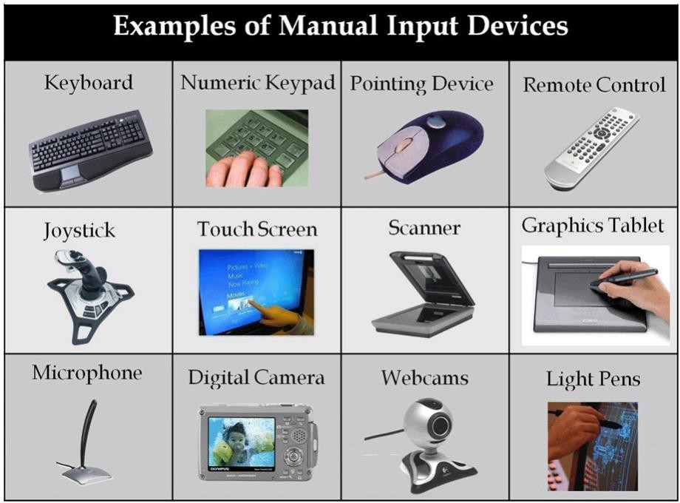

Example of Input Devices:-
1. Keyboard | 2. Mouse (pointing device) | 3. Microphone
4. Touch screen | 5. Scanner | 6. Webcam
7. Touchpads | 8. MIDI keyboard | 9.
10.Graphics Tablets | 11.Cameras | 12.Pen Input
13.Video Capture Hardware | 14.Microphone | 15.Trackballs
16.Barcode reader | 17.Digital camera | 18.Joystick
19.Gamepad | 20.Electronic Whiteboard | 21.

Note: The most common use keyboard is the QWERTY keyboard. Generally standard Keyboard has 104 keys.

Central Processing Unit (CPU)
A CPU is brain of a computer. It is responsible for all functions and processes. Regarding computing power, the CPU is the most important element of a computer system.

The CPU is comprised of three main parts :
- Arithmetic Logic Unit (ALU): Executes all arithmetic and logical operations. Arithmetic calculations like as addition, subtraction, multiplication and division. Logical operation like compare numbers, letters, or special characters
- Control Unit (CU): controls and co-ordinates computer components.
  - Read the code for the next instruction to be executed.
  - Increment the program counter so it points to the next instruction.
  - Read whatever data the instruction requires from cells in memory.
  - Provide the necessary data to an ALU or register.
  - If the instruction requires an ALU or specialized hardware to complete, instruct the hardware to perform the requested operation.
* Registers :Stores the data that is to be executed next, "very fast storage area".

Primary Memory:-

- RAM: Random Access Memory (RAM) is a memory scheme within the computer system responsible for storing data on a temporary basis, so that it can be promptly accessed by the processor as and when needed. It is volatile in nature, which means that data will be erased once supply to the storage device is turned off. RAM stores data randomly and the processor accesses these data randomly from the RAM storage. RAM is considered "random access" because you can access any memory cell directly if you know the row and column that intersect at that cell.

- ROM (Read Only Memory): ROM is a permanent form of storage. ROM stays active regardless of whether power supply to it is turned on or off. ROM devices do not allow data stored on them to be modified.

Secondary Memory:-
Stores data and programs permanently: its retained after the power is turned off

- Hard drive (HD): A hard disk is part of a unit, often called a "disk drive," "hard drive," or "hard disk drive," that store and provides relatively quick access to large amounts of data on an electromagnetically charged surface or set of surfaces.

- Optical Disk: An optical disc drive (ODD) is a disk drive that uses laser light as part of the process of reading or writing data to or from optical discs. Some drives can only read from discs, but recent drives are commonly both readers and recorders, also called burners or writers. Compact discs, DVDs, and Blu-ray discs are common types of optical media which can be read and recorded by such drives. Optical drive is the generic name; drives are usually described as "CD" "DVD", or "Bluray", followed by "drive", "writer", etc. There are three main types of optical media: CD, DVD, and Blu-ray disc. CDs can store up to 700 megabytes (MB) of data and DVDs can store up to 8.4 GB of data. Blu-ray discs, which are the newest type of optical media, can store up to 50 GB of data. This storage capacity is a clear advantage over the floppy disk storage media (a magnetic media), which only has a capacity of 1.44 MB.

- Flash Disk

A storage module made of flash memory chips. A Flash disks have no mechanical platters or access arms, but the term "disk" is used because the data are accessed as if they were on a hard drive. The disk storage structure is emulated.

